Complete the information in the table for 1H NMR.

NMR nuclei observed: H¹
Solvent: CDCl₃
NMR field strength: 400MHz

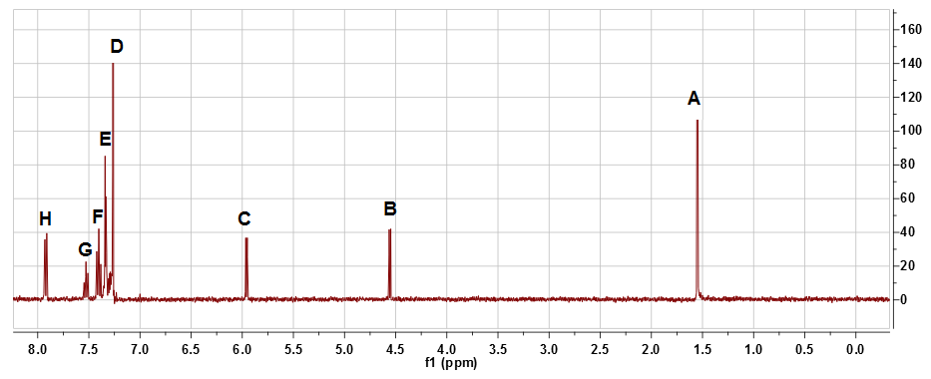

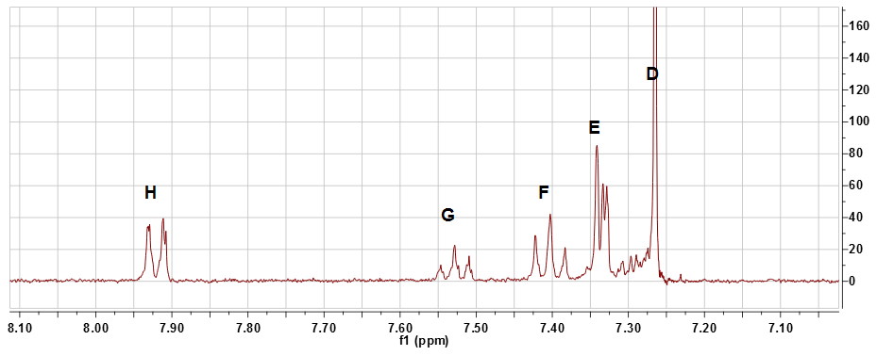

Signal | δ (ppm) | Multiplicity (s,d,t,q,m) | J (Hz) | Assignments
A | 1.55 | s | N/A
B | 4.55 | s | N/A
C | 5.97 | s | N/A
D | 7.26 | s | N/A
E | 7.33 | m | N/A
F | 7.38  7.40  7.42 | t | 8
G | 7.50  7.52  7.54 | t | 8
H | 7.91  7.93 | d | 8

